https://lh6.googleusercontent.com/JVsqziSh35sWH6EjDeZAszed7uaL8Am_o_omH5ZjZPi4ESKdGaoV3wibxSoML-Np-0FHOcxp0dfQ0vcnj1ILsYoIultjm78C2InTrx2useaBE20RY89SYMZIoBpfZ3DCRALEf76t

**Business Management Web Application**

11.01.2020

**─**

Huynh Thanh Dang

TMA Solutions

10 Dang Van Ngu Street, 10 Ward, Phu Nhuan District, Ho Chi Minh City

**Old Project**

Name: ISC Student Management Application

Some features for ADMIN:

* CRUD for Learning Program
* CRUD for Student
* CRUD for Course
* CRUD for Subject
* CRUD for University and Major
* CRUD for Company
* CRUD for WorkTrack: fee refund for student when they finish their internship program at company that is a member of Quang Trung Software City
* CRUD for Admin

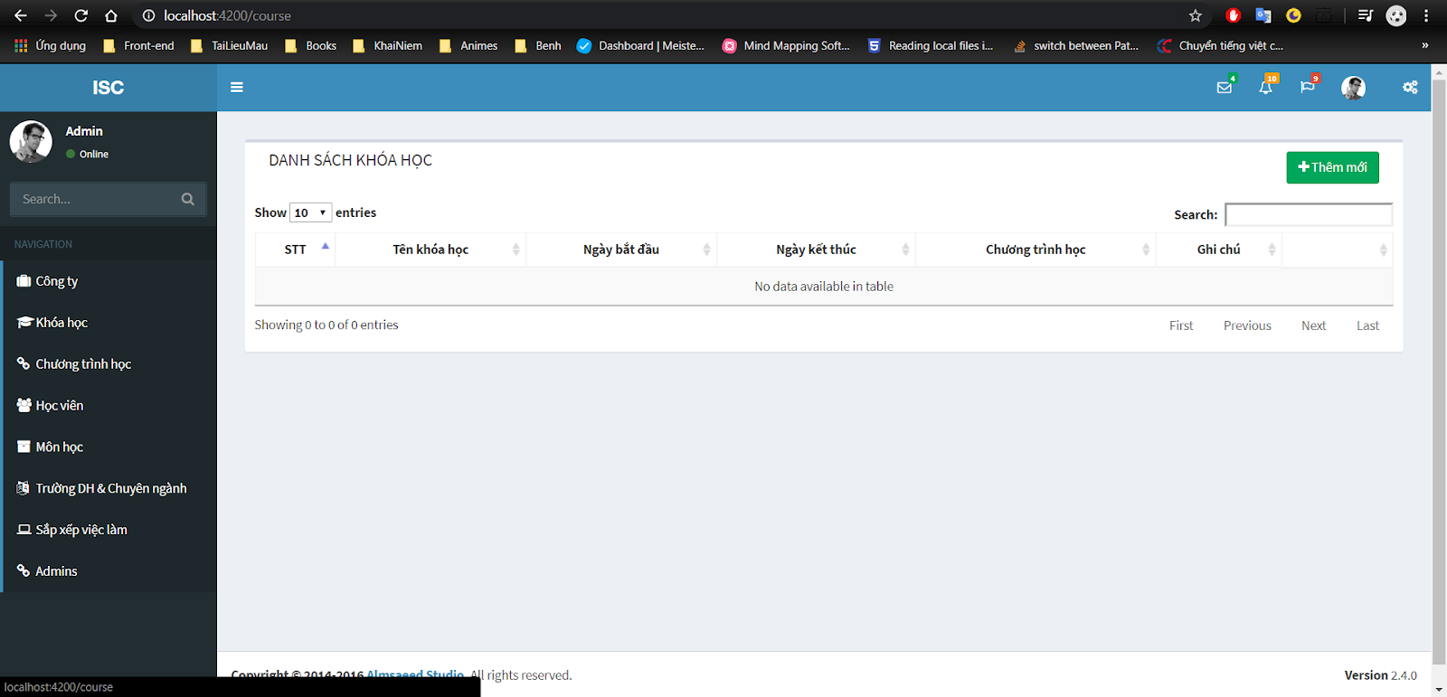

**BMWA Project**

